

REGULATIONS MADE IN TERMS OF

Identification Act 21 of 1996

section 17

Identification Regulations

Government Notice 96 of 2001

([GG 2533](http://www.lac.org.na/laws/2001/2533.pdf))

came into force on date of publication: 18 May 2001

The Government Notice which issues these regulations repeals the regulations   
published in RSA GN R.749/1972 and SWA AG GN 13/1980, and all amendments thereof.

The previous regulations were issued under the RSA Identity Documents in South West Africa Act 37 of 1970 and the SWA Identification of Persons Act 2 of 1979, and deemed to have been made under the Identification Act 21 of 1996 by section 19(2) of that Act.

**as amended by**

**Government Notice 136 of 2018 (**[**GG 6647**](http://www.lac.org.na/laws/2018/6647.pdf)**)**

**came into force on date of publication: 13 July 2018**

**Government Notice 22 of 2020 (**[**GG 7116**](http://www.lac.org.na/laws/2020/7116.pdf)**)**

**came into force on date of publication: 14 February 2020**

**Government Notice 155 of 2021 (**[**GG 7**](http://www.lac.org.na/laws/2021/7583.pdf)**583)**

**came into force on date of publication: 19 July 2021**

ARRANGEMENT OF REGULATIONS

1. Definitions

2. Applications for identity document

3. Issue of identity documents

4. Proof of registration

5. Submission of identity document or proof of registration

6. Cancellation of identity documents of deceased persons

7. Applications for duplicate or improved identity document

8. Fingerprints

9. Short title

ANNEXURE A

Application for Identity Document

ANNEXURE B

Data Update Acquisition Application Form

ANNEXURE C

National Identity Card

ANNEXURE D

Application for Duplicate or Improved Identity Document

**Definitions**

**1.** In these regulations, unless the context indicates otherwise, any expression to which a meaning has been assigned in the Act bears that meaning, and -

“Annexure” means the appropriate annexure to these regulations;

“the Act” means the Identification Act, 1996 (Act No. 21 of 1996).

**Applications for identity document**

**2.** (1) Subject to subregulation (2), an application for an identity document by a person contemplated in section 5 of the Act must be made -

(a) if the person applies for the first time, on Form 3-l/0066 a specimen of which is set out in Annexure A; and

(b) if the person applies for the replacement of an identity document issued in terms of any law repealed by section 19(1) of the Act, on Form 3-l/0067 a specimen of which is set out in Annexure B.

(2) Every person who, on or after the commencement of the Act becomes 16 years of age and who is not in possession of an identity document, must within three months from the date on which he or she attained the age of 16 years apply for an identity document.

**Issue of identity documents**

**3.** An identity document issued in terms of section 5 of the Act shall be in the form of a card, a specimen of which is set out in Annexure C, and -

(a) when issued to a Namibian citizen, be blue in colour; and

(b) when issued to a non-citizen who is the holder of a permanent residence permit, be pink in colour,

and shall in addition to the particulars mentioned in section 5(3)(a) to (d) of the Act contain the signature or mark of the person to whom it was issued and -

(i) a machine readable zone; and

(ii) a quick response code.

[regulation 3 substituted by GN 22/2020]

**Proof of registration**

**4.** A proof of registration must in the case of an application -

(a) referred to in regulation 2(1)(a), be in the form as set out in paragraph D of the form mentioned in that regulation;

(b) referred to in regulation 2(1)(b), be in the form as set out in paragraph D of the form mentioned in that regulation.

**Submission of identity document or proof of registration**

**5.** (1) If -

(a) an identity document or a proof of registration does not correctly reflect the particulars of the person to whom it was issued; or

(b) an identity document no longer contains a photograph which is a recognizable image of the person to whom it was issued,

such person must within 30 days after having become aware of the incorrectness of such identity document or proof of registration or of the fact that the photograph contained in such identity document is no longer a recognizable image of him or her, hand over to the Minister such identity document or proof of registration in compliance with section 12 of the Act.

(2) Any identity document or proof of registration of which the Minister has by virtue of section 12 of the Act obtained possession and which is required to be cancelled in terms of that section, must be cancelled by imprinting the words “CANCELLED” on the identity document or proof of registration.

**Cancellation of identity documents of deceased persons**

**6.** (1) An uncancelled identity document or proof of registration of a deceased person which was handed over to a registrar or assistant registrar referred to in section 13 of the Act, or which was seized by such registrar or assistant registrar in terms of that section, must be cancelled in the manner prescribed in regulation 5(2).

(2) The identity number of the deceased person referred to in subregulation (1) must be retained on the population register for a period of 12 months after the cancellation of the identity document in question.

**Applications for duplicate or improved identity document**

**7.** (1) If an identity document issued to a person in terms of section 5 of the Act -

(a) is lost, damaged, destroyed or stolen, a duplicate identity document; or

(b) is surrendered to the Minister in terms of section 12 of the Act, an improved identity document,

must be issued to such person, but only if he or she -

(i) in duplicate completes a form set out in Annexure D;

(ii) subject to subregulation (2), pays a fee of -

(aa) N$150 for the first duplicate;

(bb) N$300 for the second duplicate;

(cc) N$450 for the third duplicate;

(bb) N$600 for the fourth duplicate;

(bb) N$750 for the fifth or any subsequent duplicate; and

[The lettering of the paragraphs is incorrect in the *Government Gazette,* as reproduced above.]

(iii) in the case of a damaged identity document, hand that document over to the Minister.

[The verb “hand” should be “hands” to be grammatically correct.]

(2) A person shall not pay a fee contemplated in subregulation (1)(ii), if his or her application for a duplicate or improved identity document is for purposes of -

(a) replacing the identity document issued to him or her 20 years earlier; or

(b) inserting a new photo, signature or surname in his or her identity document.

(3) A duplicate form referred to in subregulation (1)(i) serves as a proof of registration.

[subregulation (1) substituted by GN 136/2018 and by GN 155/2021]

**Fingerprints**

**8.** The fingerprints and palmprints required to be taken in terms of section 8 of the Act, must be taken by a person authorized thereto by the Minister by imprinting such fingerprints and palmprints on any of the forms set out in Annexure A, B or D, whichever may be applicable.

**Short title**

**9.** These regulations are called the Identification Regulations.

ANNEXUREs

To view content without printing, scroll down.

To print at full scale (A4), double-click the icon below.





[Annexure C substituted by GN 22/2020]



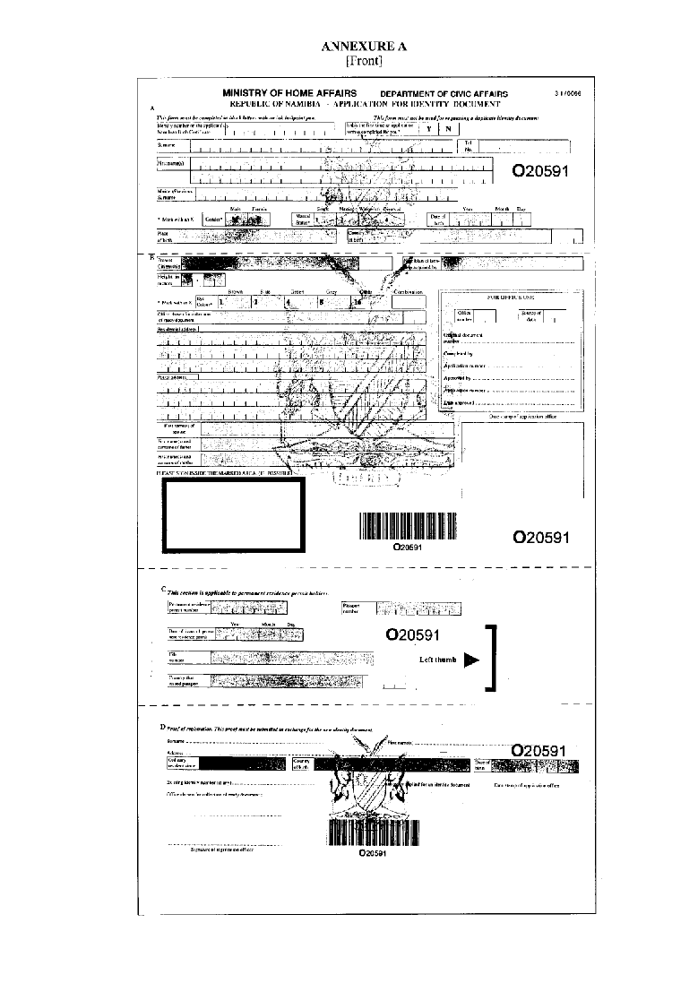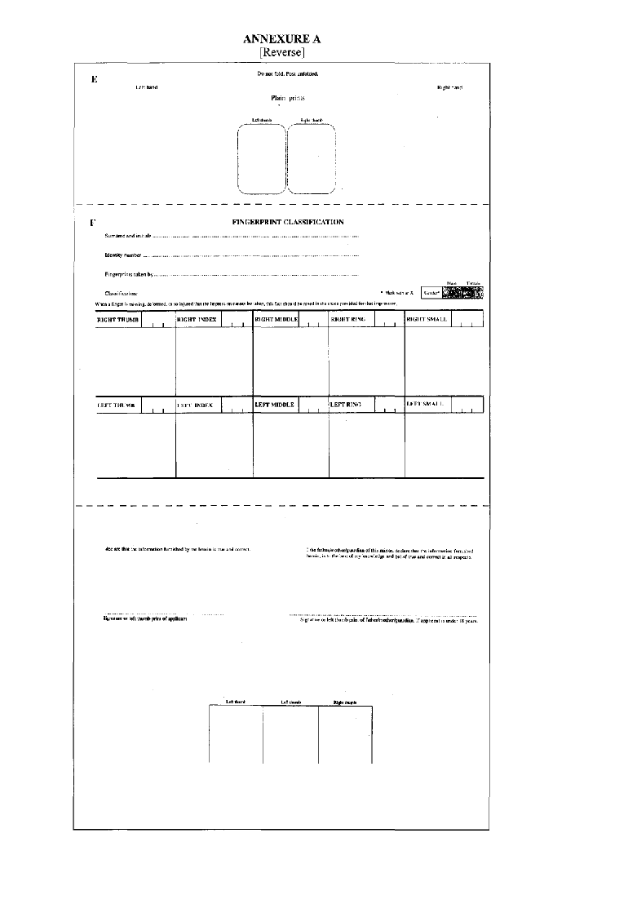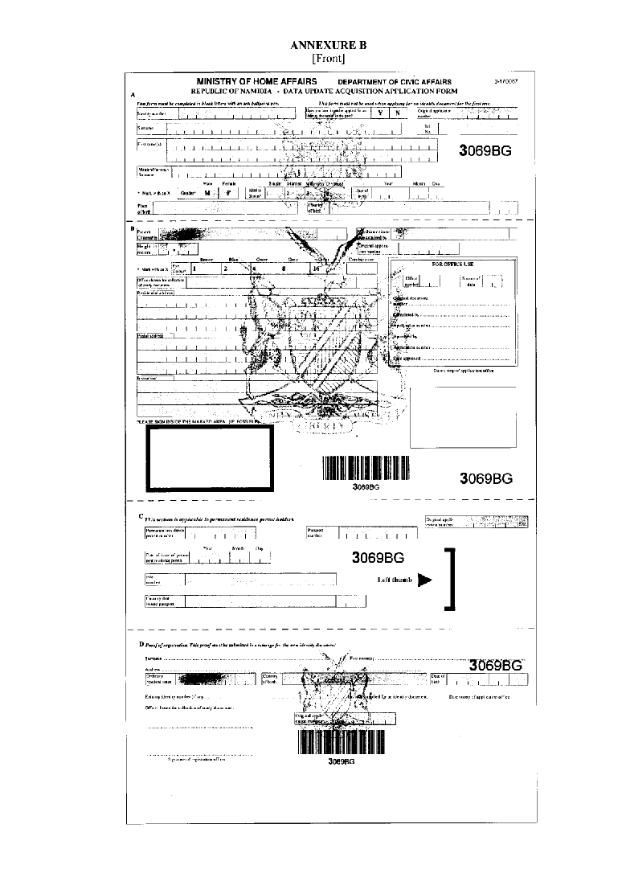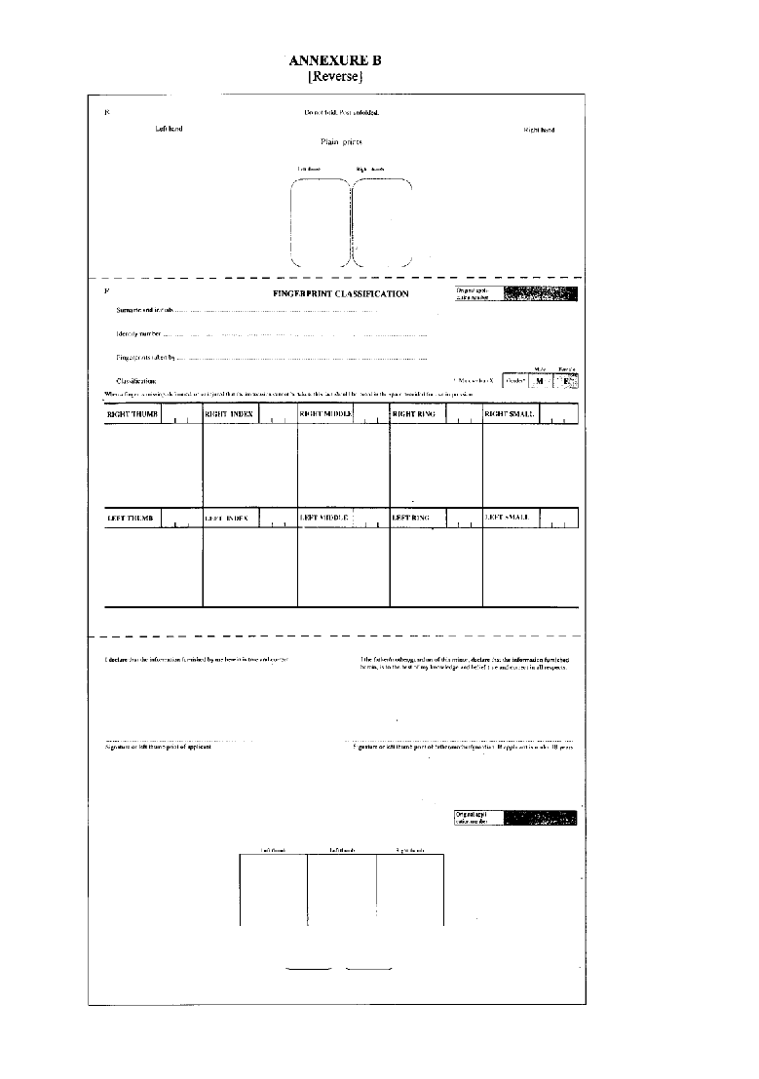

[Annexure C substituted by GN 22/2020]

